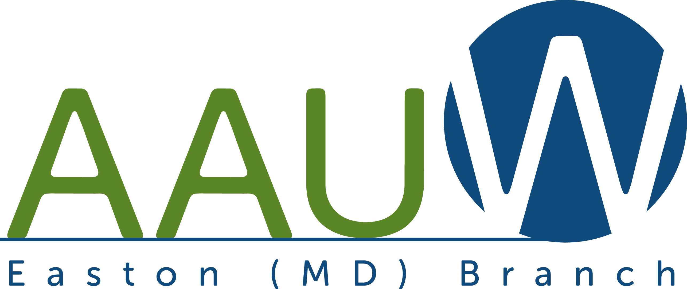

The American Association
Of
University Women

Easton Branch



Member Directory
2015-16

AAUW MARYLAND INFORMATION

OFFICERS
Co-President- Dorothy Fraquelli 410-828-1711
Co-President- Sandra Smith 202-714-4017
Co-Program - Susan Wierman 410-821-9521
Co-Program - Markonette Richardson 240-605-4801
Membership - Angela Mickalide 301-949-0138
Finance- Judith Flood 301-503-2032
Co-Public Policy VP- Louise Chatlynne 301-330-9349
Co-Public Policy- Anita Rosen 301-384-0331
AAUW Funds VP- Christine Schmitz 410-795-5091
Communications - Bernadette Low 301-231-0109
Webmaster- Eileen Menton 410-206-6318
Co-Secretary- Paula Hirsch 301-972-6986
Co-Secretary- Mary Anne Williams 301-662-7837

More info at http://aauw-md.aauw.net.

AAUW National Association Information

Executive Director- Linda Hallman, CAE
AAUW President- Patricia Fae Ho
AAUW Customer Serice 800-326-AAUW (2289)
AAUW 1111 Sixteenth Street, NW
Washington, DC 20036
202-785-7700
connect@aauw.org

Want to know more about AAUW?

Check out www.aauw.org for information about the National organization.



MISSION STATEMENT

AAUW advances equity for all women and girls through advocacy, education, philanthropy, and research

EASTON BRANCH
VISION STATEMENT

To be recognized as a viable, visible, action-oriented force on the Eastern Shore for education and equity for women and girls

AAUW EASTON BRANCH OFFICERS

President- Linda Tebbs 410-763-8265
Membership- Janet Harford 410-476-5961
Co-Program- Lois Krum 410-820-5607
Co-Program- Pat Crane 410-819-3653
Secretary- Sibyl Cochran 410-822-1108
Treasurer- Mettah Kollmann 410-770-6271
Membership Treas.- Suzanne Smith 410-822-4324

COMMITTEE CHAIRS/APPOINTMENTS

AAUW Funds- Sharron Cassavant 410-822-6323
Public Policy- Elaine Wilson 410-770-5049
Communications- Pat Crane 410-819-3653
(newsletter/publicity)-
Newsletter Editor- Kay Wendowski 410-822-7457

COLLEGE PARTNER

Chesapeake College continues to partner with AAUW as a College/University Partner Member. AAUW works closely with partners to enhance the educational experience of women. All Chesapeake students can choose to have free e-student affiliate membership. We look forward to developing programs of interest to the College.

MEMBERSHIP INFORMATION

Any woman or man holding an associate or equivalent, baccalaureate, or higher degree from a qualified educational institution is qualified for membership in AAUW. An associate degree includes associate of arts (AA), associate of science (AS), associate of applied science (AAS), associate of arts and science (AA&S), and associate of applied arts (AAA). An “equivalent degree” will usually apply to the RN diploma and associate degrees awarded by business colleges and school.

AAUW Easton Branch Dues
(July 1, 2015-June 30, 2016)
National- $49.00*
State- 10.00
Branch- 10.00
Total- $69.00

Life Members- $20.00 ($10 state and $10 Branch)
*$46 is deductible as a charitable contribution.
Student Affiliate Member- $17 for national membership

New members joining at Shape the Future meetings pay 50% of National dues and full dues for the state and branch.

Give a Grad a Gift- AAUW members may give a recent graduate, a friend, daughter, granddaughter, or niece, a free AAUW membership. More at https://svc.aauw.org/join/gradgift.cfml.

STATE MEETINGS

October 3, 2015 AAUW Maryland Board and Program Meeting

April 30, 2016 Maryland State Convention in Howard County

July 23, 2016 Maryland Leadership Training

Additional Names and Notes

INTEREST GROUPS

Afternoon Reading Group- Fourth Monday of every month at 1:00 PM

Movie Group- Fourth Friday of every month at 1:00 PM

BOOK SALE

Each year, normally in September, our branch sells used books, DVDs, plants, and costume jewelry as our main fundraiser to support the various educational fund programs of AAUW by donating all profits from the book sale. No sale is currently planned since we cannot find suitable space.

BOARD MEETINGS

Usually scheduled for the Tuesday preceding a monthly meeting at 4:00 pm at a board member’s home. All members are welcome to attend. Call Pat Crane to determine location for a particular month or check the newsletter.

Web Site

The branch’s website, http://easton-md.aauw.net, is maintained by Sharron Cassavant. Please check it out as a valuable source of activities of our branch. Sharron welcomes additional information and pictures to add to this site. Contact her about how to access the member-only information.

Easton Branch Program Calendar

When? | What? | Where?
September 21  6:00 PM | Salad Daze Supper | St. Marks Church  Easton, MD
October 20  7:00 pm | History of Unionville, Harriette Lowery, Speaker | Bayleigh Chase (was William Hill Manor)
October 26  7:00 pm | Halloween Ghost Tour of Easton | Meet at Tidewater Inn
November 11  9:30 am | Veterans Day Salute to Women | VFW Post
December 13  12:15 pm | Longwood Gardens  (Trip and Fund Raiser) | Meet at Firehouse in Easton
January 16  10:00 am | TBD | TBD
February 20  10:00 am | Book Discussion  Book TBD | St Michaels Library
March 12  12:00 pm | Women Who Make a Difference | Miles River Yacht Club, St. Michaels
April 16  12:00 pm | Annual Business Meeting, Elections | TBA
May 16  6:00 pm | May Dinner | TBD
June  12:00 pm | Planning Meeting | TBD

Fundraising Trips

These trips are open to both members and non-members. All trips depart and return to the Firehouse in Easton. Stops may be made on Kent Island or Cambridge as appropriate and upon request. More details will be provided in the newsletters. Profits support the AAUW Easton Branch Mature Women’s Grant (MWG) Program.
When? | What?
December 13  12:15 pm | Trip to Longwood Gardens to celebrate the season. Enjoy a delicious buffet luncheon and then watch the open-air fountain display.
 | Other trips are under consideration for the Spring.

New Members

Rev 9/9/2015

Alemnesh Abebe Gedamu
PO Box 3693
Salisbury, MD 21802
410-543-0189
Micro06@live.com

Sarah N Acquah
614 Irene Ave
Salisbury, MD 21801
410-742-2097
snacquah@umes.edu

Jo Ann Asparagus- Murray
9632 Macks Lane
McDaniel, MD 21647
410-822-4808
jadam@atlanticweb.net

Joan Beyda
7144 Fir Street
Easton, MD 21601
443-385-0702
joancbeyda@gmail.com

Judy Bottorf
29276 Pin Oak Way
Easton, MD 21601
410-820-7130
judybottorf@goeaston.net

Dr. Sharron Cassavant
29744 Amanda’s Way,
Easton, MD 21601
410-822-6323
cassava39@goeaston.net

Sibyl Cochran
29820 Hillary Avenue
Easton. MD 21601
410-822-1108
sibylcochran@ymail.com

Evelyn Corbin
315 S. Aurora Street
Easton, MD 21601
410-822-6949
pecorbin@goeaston.net

Patricia Crane
28410 Pinehurst Circle
Easton, MD 21601
410-819-3653
chuckpat@goeaston.net

Phyllis Dell
28427 Pinehurst Circle
Easton, MD 21601
410-822-7902
ptdell@goeaston.net

Jane Escher
27247 Trippe Road
Easton, MD 21601
410-822-4452
lowefarm@juno.com

Kathleen Francis
105 Third Haven Heights
Easton, MD 21601
410-822-5541
kitty199@verizon.net

Reba Goslee
736 S Park Drive
Salisbury, MD 21804
410-742-3705

Marilyn Hale
28504 Woods Drive
Easton, MD 21601
410-819-3757
mphale@goeaston.net

Eleanor Hairston
313 Elm Street
Easton, MD 21601
410-822-4042
wehairston2@verizon.net

Janet Harford
29798 Bunker Hill Lane,
Trappe, MD 21673
410-476-5961
jharford@shorecable.com

Dr. Judith Hegarty
8275 Mueller Drive
Easton, MD 21601
410-819-3749
Hegarty22@verizon.net

Dr. Priscilla Hilliard
8724 Sky View Drive
Easton, MD 21601
410-822-4967
eastonbelle@goeaston.net

Edythe Humphries
PO Box 274
Royal Oak, MD 21662
410-745-2925
ehphoebe@hotmail.com

Carter Jump
4769 Sailors Retreat Rd
Oxford, MD 21654
410-822-1979

Mettah Kollmann
7600 Easton Club Drive
Easton, MD 21601
410-770-6271
mettah.kollmann@goeaston.net

Lois Krum
32 Park Lane
Easton, MD 21601
410-820-5607
lkleahrose@gmail.com

Judy Lawrence
6343 Canterbury Drive
Easton, MD 21601
410-819-8029
boblawrence1@msn.com

Annabel Lesher
26965 Miles River Road
Easton, MD 21601
410-310-6114
annabel@the-harbor.org

Dr. Joan Leukhardt.
29797 Dustin Avenue
Easton, MD 21601
410-690-3554
drnaoj@goeaston.net

Nancy Lewis
53 Londonderry Drive
Easton, MD 21601
410-820-4569
nansublewis@msn.com

Elizabeth Matthews
30514 Danwood Drive
Delmar, Md 21875
410-742-9186
ernie29@comcast.net

Melissa McLoud
8945 High Banks Drive
Easton, MD 21601
443-786-0261
mmcloud27@gmail.com

Lynn Mielke
28415 Pinehurst Circle
Easton, MD 21601
410-819-3797
lmielke@lionheartlaw.com

Sona Morrison
922 Schumaker Manor Dr
Salisbury, MD 21804
410-546-0730
sonamorrisonlaw@earthlink.net

Barbara Reed
114-E Lynchburg Street
Chestertown, MD 21620
410-770-2754
Lthe-br@outlook.com

Angela Richardson
7140 Fir Street
Easton. MD 21601
202-577-1094
angelricher@yahoo.com

Diane Sausser
23274 Holly Park Drive
Preston, MD 21655
410-673-2579
dianesausser@aol.com

Lee Schatz
507 S. Washington St
Easton, MD 21601
410-770-3389
mleeschatz@aol.com

Virginia Shaw
27247 Trippe Road
Easton, MD 21601
410-822-4452
Artbyginny74@gmail.com

Eunice Shearer
28867 Jasper Lane
Easton, MD 21601
410-822-0607
eunyb@goeaston.net

Cyndi Slacum
205 Virginia Ave.
Cambridge, MD 21613
410-463-0457
cslacum@esahec.org

Deborah Smith
26226 Langs Landing Rd
Oxford, MD 21654
410-226-5624
justdsmith@atlanticbb.net

Suzanne Smith
7566 Seventeenth Drive
Easton, MD 21601
410-822-4324
seandy50@goeaston.net

Linda Tebbs
30621 Kingston Road
Easton MD 21601
410-763-8265
linda.tebbs@gmail.com

Kay Wendowski
28545 Congressional Ct
Easton, MD 21601
410-822-7457
ghs51@goeaston.net

Dr. Fran White
9199 High Banks Drive
Easton, MD 21601
410-770-8384
fwhite645@gmail.com

Susan Williams
28494 Clubhouse Drive
Easton, MD 21601
443-385-0344
swanfall@goeaston.net

Elaine Wilson
28242 Widgeon Terrace
Easton, MD 21601
410-770-5049
ewilson@chesapeake.edu

Connie Wolfe
27342 Rest Circle
Easton,MD 21601
410-819-6789
corneliawolfe@gmail.com

